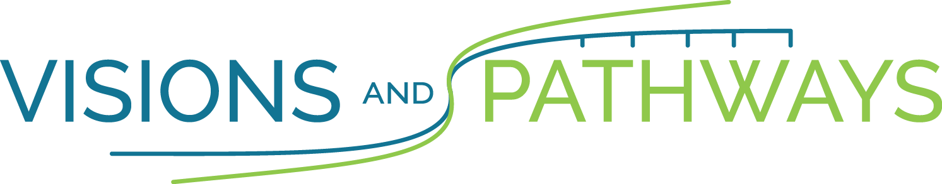

Liability Waiver

I, intending to be legally bound, hereby for myself, my heirs, executors, and administrators, waive and release any and all rights and claims I may have against Visions and Pathways, the County of Somerset, Race Forum, all sponsors, and other persons or organizations connected with the above named event, and their respective agents, employees, officers, volunteers, representatives, successors, and assignees for any and all injuries that may be suffered by me in connection with this event. Further, I hereby certify that I am physically able to participate in this event and hereby grant the right to publish my name in the news media and use my likeness in any photographic record for the Run and Walk For Our Youth’s Future.

Signature of Participant____________________________ Date: _____________

Signature of Parent/Guardian _______________________ Date: _____________
(if participant is under 18)

